School Survey Results from Sunday September 24th, 2023

The Leroy and Barry ran nine transects just outside the established Seal Island box on Sunday, September 24th over a 2.5-hour period, from 22:00-00:30.

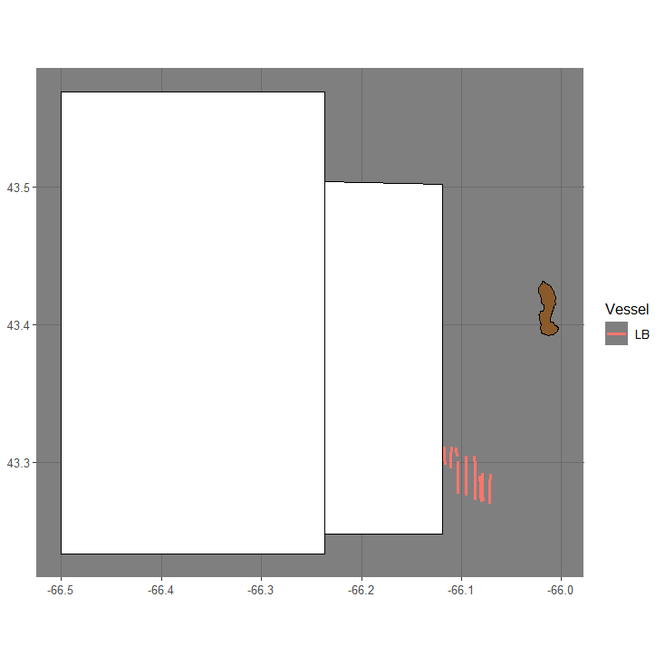

Figure 1. Transects ran with respect to the German Bank and Seal Island boxes.

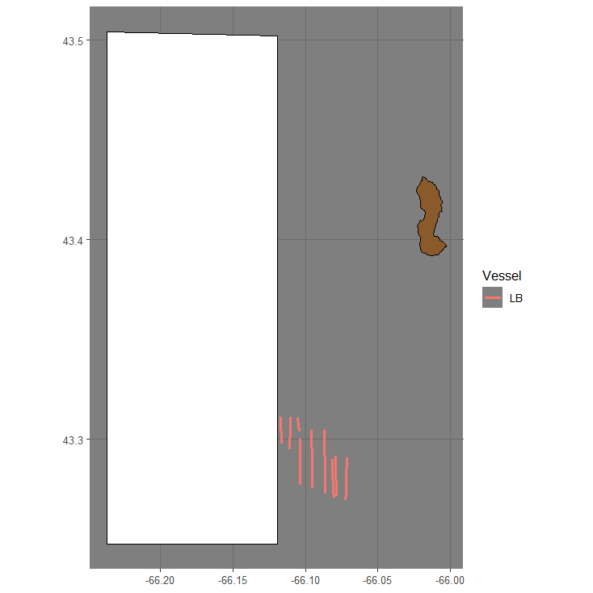

Figure 2. Transects ran with respect to the Seal Island box.

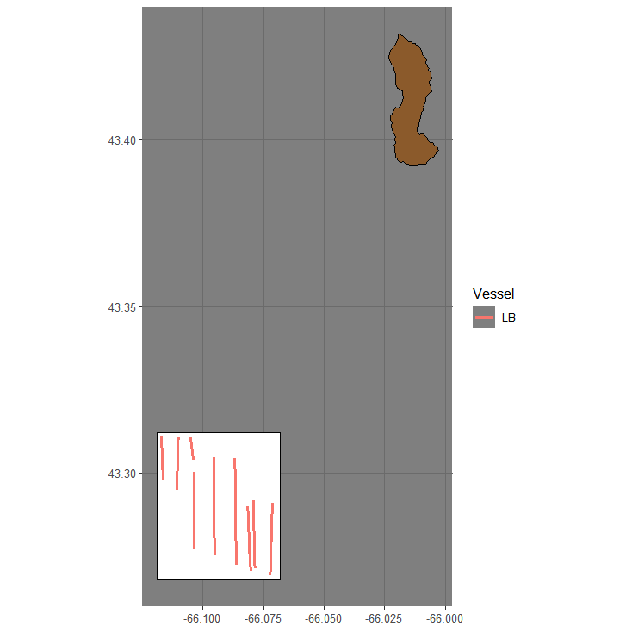Figure 3. Transects ran and the survey box used for area calculation.

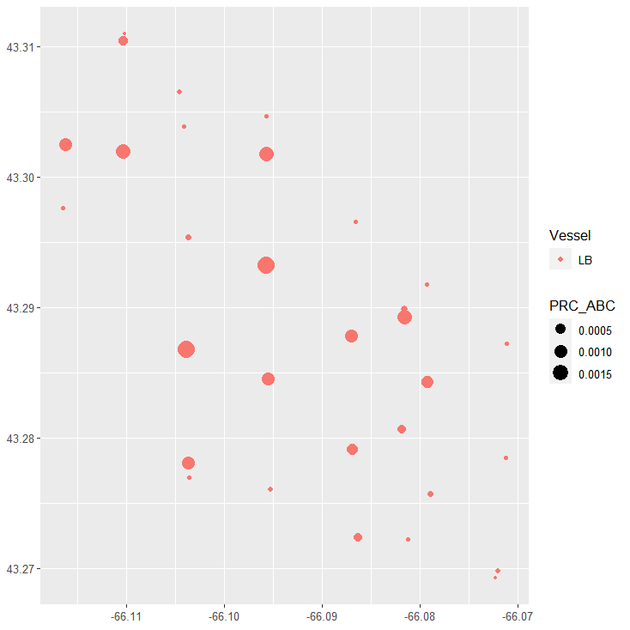

Figure 4. PRC Area Backscattering Coefficient (m2/m2) for each transect and cell using a grid of 1km.

Acoustic Equipment

The vessel was equipped with a Simrad ES38-18/200-18C combi (2-in-1) transducer prior to the survey that contains a 38kHz split beam and 200 kHz single beam transducer. Data was logged to the computer hard-drive for post-processing. The vessel was calibrated on 38kHz before the survey.

Results

The results are subject to change as DFO will re-evaluate data editing, area estimation and apply a target strength. Preliminary biomass prediction using standardized parallel transects is **46,478 mt**.

Table 1. Transect details.



Table 2. Acoustic survey results - transects are listed from greatest to least backscatter.



Figure 5. Snip from the transect with the greatest backscatter.

Table 3. Survey summary.

